# Section 14-1: The Buddha Meets King Seniya Bimbisāra of Magadha

In the previous sections (13-1 & 13-2), we explored how the newly awakened Buddha journeyed far and wide on foot, spreading the Dhamma for the welfare and happiness of many. During this time, he accomplished several significant milestones. He established the first Bhikkhu Sangha, training and dispatching monks to teach the Dhamma for the benefit of all. He also gained a devoted group of lay followers who provided support for the flourishing of his dispensation.

# The Buddha Arrives at Rājagaha with a Large Group of Monks

At the beginning of this section, we see the Buddha continuing his teachings while gathering both disciples and lay supporters. This period is generally considered to have begun when the Buddha, accompanied by a large assembly of monks, arrived in Rājagaha, the capital of Magadha, from Gaya. This marked the completion of his third walking tour.

It is believed that when the Blessed One entered Rājagaha for the second time in his life, he was in the prime of his youth—just thirty-five years old. [1] He remained in and around Rājagaha for nearly three years, continuing to share the Dhamma with those who sought liberation.

The *Vinaya Pitaka* provides the following account of the Buddha’s arrival in Rājagaha:

“*After staying at Gayāsīsa for as long as he liked, the Buddha set out wandering toward Rājagaha with that large sangha of one thousand monks, all of them previously dreadlocked ascetics. When he eventually arrived, he stayed in the Cane Grove at the Suppatiṭṭha Shrine.”*  [2]

According to scriptures and legends, the three rainy seasons the Buddha spent in Rājagaha were filled with many remarkable events. In this section, we will focus on these significant occurrences, from the time the Blessed One entered Rājagaha until his departure for Kapilavattu to visit his father and relatives.

## Evidence regarding second to fourth rainy seasons (vassa) spent in and around Rājagaha

1) The second Rains retreat was in the Great Monastery at Bamboo Wood, relying on Rājagaha the third and fourth likewise (he was also there) [3]

*( dutiyaṁ Vassaṁ Rājagahaṁ upanissāya Veḷuvane Mahāvihāre; tatiyacatutthāni pi tattheva)*

2) The Protector dwelt for the second, third, and also the fourth Rains Retreat in the very agreeable Bamboo Wood, near the delightful and most excellent city Rājagaha by name, which has streets full of shops having various treasures [4]

*(Nātho nāna-ppakāra-ratana-āpaṇa-panti-vīthi ramme pavara-Rājagaha-abhidhāne pure kanta-tara-Veḷuvane pi, dutiye tatiye catutthe Vasse pi, vāsaṁ akāsi)*

### Location of Magadha

Ancient Magadha [5] was located in what is now the state of Bihar, India. During the time of the Buddha, its northern border was the Ganges River, while the Vindhya Mountain range marked its southern boundary. The Sona River formed its western limit, and to the east lay the state of Aṅga. Rājagaha, the capital of Magadha, was one of the most powerful cities among the sixteen great states of that era.

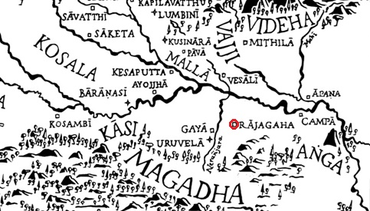

**Map showing the ancient Magadha Kingdom** **during the time of the Buddha [6]**

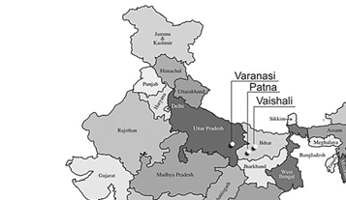

**Modern day map of Bihar state (Magadha) of India [7]**

### Places where the Buddha stayed during the three vassa season

According to scriptures and legend, during the three years the Blessed One resided in Rājagaha, he spent time at the Bamboo Grove Monastery as well as Vulture’s Peak (also known as the Eagle Peak or Gijjhakūṭa) in the hilly outskirts of the city. He may have also stayed at a few other locations during this period.

The *Aṅguttara Nikāya* (AN 7:61) records that on one occasion, while dwelling among the Bhaggas at Suṃsumāragira in the Deer Park at Bhesakalā Grove, the Buddha perceived with his divine eye that Venerable Mahā Moggallāna was struggling with his meditation at Kallavālamuttagāma, a village in Magadha. In response, the Blessed One appeared there to assist him. This account indicates that before the second rainy season, during his stay in Rājagaha, the Buddha visited Suṃsumāragira—identified with present-day Chunar, approximately 318 km from Rājagaha (see map).

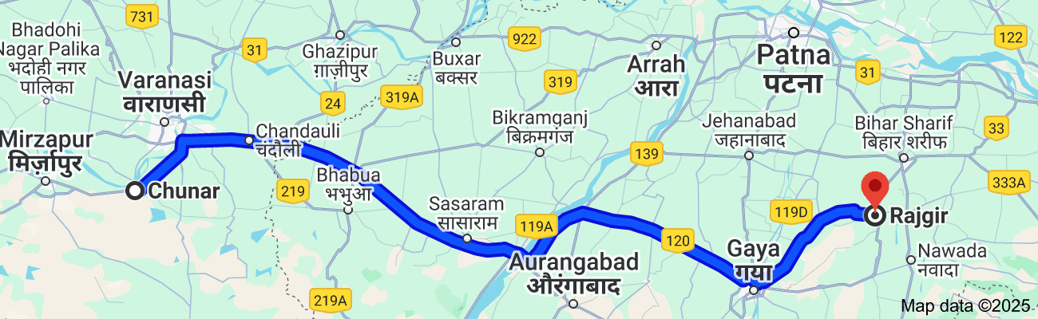

**Map showing location of Rajgir (ancient Rājagaha) and Chunar (ancient Suṃsumāragira**) [8]

In the Bodhirājakumāra Sutta (MN: 85), there is a statement confirming that on one occasion, the Buddha stayed among the Bhaggas at Suṁsumāragira in the Bhesakaḷā Grove, the Deer Park. Prince Bodhi recounted:

*“Then my nurse, carrying me on her hip, went to the Blessed One at Bhesakaḷā Grove. After paying homage to him, she said: ‘Venerable sir, this Prince Bodhi goes for refuge to the Blessed One, to the Dhamma, and to the Sangha of bhikkhus. May the Blessed One remember him as a lay follower who has taken refuge in him for life.’”*

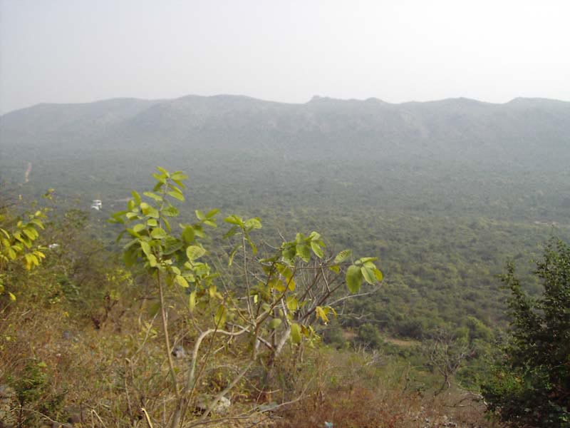

**Present-day picture of Rajgir** [9]

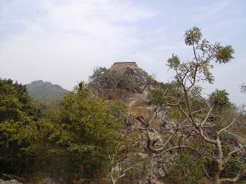

**Gijjakuta Hills in Rajgir [10]**

# Significant Events in Rājagaha

When the Buddha arrived in Rājagaha with a large Saṅgha of 1,000 arahants, he stayed at Suppatiṭṭha Cetiya, a forest grove of banyan trees located outside the city limits.

One source record:

*“…on the full moon of Phussa (December–January), the Blessed One, accompanied by the one thousand arahants, went to Rājagaha…”*[11]

## King Seniya Bimbisāra Meets the Buddha

According to the *Vinaya Piṭaka*, news of the Buddha’s arrival quickly reached King Bimbisāra. It was reported to him as follows:

*“Sir, the ascetic Gotama, the Sakyan who has gone forth from the Sakyan clan, has arrived in Rājagaha and is staying in the Cane Grove at the Suppatiṭṭha Shrine. The noble Gotama has a fine reputation: ‘He is a Buddha, perfected and fully awakened… His Teaching is excellent in the beginning, excellent in the middle, and excellent in the end. It has a true purpose and is well expressed. He proclaims a perfectly complete and pure spiritual path.’ It would be good to see such a perfected one.” [12]*

Upon hearing of the Buddha’s arrival in his kingdom, King Bimbisāra **[13]** set out to pay homage to him, accompanied by a large retinue, including 120,000 Magadhan Brahmin householders. [14]

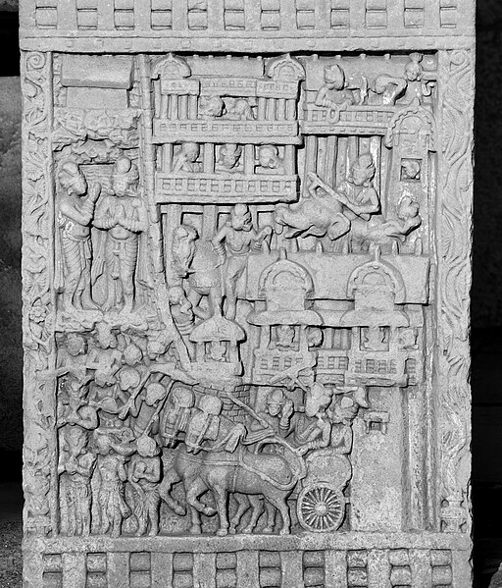

**King Bimbisara visits the Buddha [15]**

## A Profound Dhamma Teaching in Magadha: King Bimbisāra and the Brahmins Establish Faith in the Dhamma

When the people of Magadha first encountered the Buddha, along with Uruvelā Kassapa and the group of monks, they were uncertain about the true teacher. A question arose in their minds:[16]

*“Is the Great Ascetic practicing the spiritual life under Uruvelā Kassapa, or is Uruvelā Kassapa practicing under the Great Ascetic?”*

Sensing their doubts with his divine insight, the Buddha skilfully guided a dialogue with Bhikkhu Uruvelā Kassapa, illuminating the truth. With profound wisdom and compassion, he dispelled their confusion, leading them to a clear realization—the Blessed One was the true Teacher, and the monks were his disciples.

The scriptures describe the powerful moment that followed. At the conclusion of the dialogue, Uruvelā Kassapa, who had once been revered as a great spiritual leader, rose from his seat, humbly bowed before the Blessed One, and declared:

*“Sir, you are my teacher; I am your disciple. You are my teacher; I am your disciple.”[17]*

With this, a great transformation took place. Faith was firmly established in the hearts of King Bimbisāra and the large gathering of Brahmins. The light of the Dhamma had begun to shine in Magadha, dispelling ignorance and opening the path to liberation for many.

## Profound Dhamma Reflections in Magadha

According to the *Vinaya Piṭaka*, on this momentous occasion, the Buddha imparted profound Dhamma teachings to the people of Magadha, illuminating the path beyond suffering and saṁsāra. [18]

### 1) True Liberation Lies Beyond Rituals

At that time, the prevailing belief in Magadha was that fire sacrifices brought great merit and favourable outcomes in life. Many considered ritualistic offerings to be the highest form of spiritual practice. However, the Buddha, out of compassion, dispelled this misconception, revealing that no external rituals could lead to true peace and liberation. Only through earnest practice of the Dhamma could one transcend the cycle of birth and death.

To illustrate this, the Buddha instructed Bhikkhu Uruvelā Kassapa to share why he had abandoned the practice of fire sacrifices. Kassapa, once a highly esteemed ascetic devoted to ritual offerings, spoke these insightful words:

*“As a reward for the sacrifice, they promise sense pleasures—*  
*Sights, sounds, and tastes, and women, too.*  
*But knowing the stain of ownership,*  
*I found no delight in worship and sacrifice.” [19]*

With this reflection, those gathered realized the futility of worldly offerings and the impermanence of sensual pleasures. True liberation, they understood, could only be attained through wisdom and direct realization of the Dhamma.

### 2) The Revelation of the Four Noble Truths

Seeing that the hearts of King Bimbisāra and the vast assembly were receptive, the Buddha delivered a gradual discourse (*anupubbikathā*), guiding them from the understanding of generosity (*dāna*), morality (*sīla*), and the benefits of renunciation, toward the essence of the Dhamma. When their minds became clear, free from hindrances, and filled with joy and confidence, the Buddha expounded the teaching unique to all Buddhas—the Four Noble Truths:

* The truth of suffering (*dukkha*)
* The cause of suffering (*samudaya*)
* The cessation of suffering (*nirodha*)
* The path leading to the cessation of suffering (*magga*)

The *Vinaya Piṭaka* describes the extraordinary impact of this teaching:[20]

*“When the Buddha knew that their minds were ready, supple, without hindrances, joyful, and confident, he revealed the teaching unique to the Buddhas: suffering, its origin, its end, and the path. And just as a clean and stainless cloth absorbs dye properly, so too, while they were sitting right there, one hundred and ten thousand of those Brahmin householders, led by Bimbisāra, experienced the stainless vision of the Truth: ‘Anything that has a beginning has an end.’”*

At that very moment, these individuals attained *sotāpatti* (stream-entry), freeing themselves from doubt and wrong views, ensuring that they would never again be reborn in lower realms. The remaining ten thousand, though not yet reaching this realization, declared themselves lay followers, committing their lives to the path of the Dhamma.

### A Teaching of Great Significance

The *Mahāvastu*, an ancient Buddhist text, [21] states that this momentous discourse was the fourth formal Dhamma teaching of the Buddha, following the *Ādittapariyāya Sutta* (The Fire Sermon). However, no direct scriptural references have been found to confirm this claim.

Regardless, this occasion stands as a testament to the Buddha’s boundless compassion and wisdom. In a land where rituals and sacrifices had long been revered, he skilfully led countless beings toward true refuge—not in external rites, but in the unshakable realization of the Noble Truths. Through this profound teaching, the light of the Dhamma began to shine ever brighter in Magadha, touching the hearts of many and setting them firmly on the path to liberation**.**

## Sakka, the Lord of Devas, Praises the Buddha

Having attained stream-entry, King Bimbisāra was filled with devotion and gratitude. Wishing to express his reverence, he invited the Buddha and his disciples for a meal at his palace. As the Blessed One, accompanied by the great Saṅgha, made his way from the outskirts of the city into Rājagaha, an extraordinary event unfolded. *[22]*

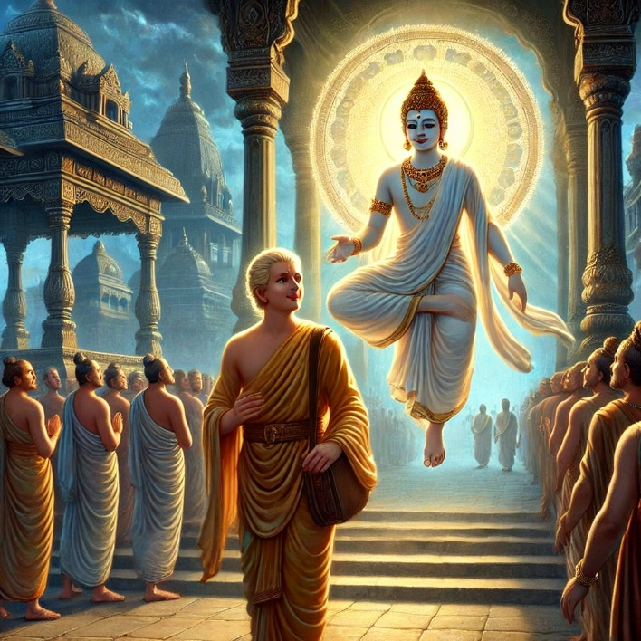

**Sakka the Lorad of the Devas descended from his celestial abode, disguised as a brahmin youth walking ahead of the Buddha and reciting beautiful verses praising the Blessed One.[23]**

Sakka, the Lord of the Devas, [24] overcome with boundless joy, descended from his celestial abode. Disguised as a young Brahmin, he walked ahead of the Buddha, extolling his supreme virtues in verses that resonated through the streets of Rājagaha:

***“The Peaceful One with the peaceful ones,*  
*Previously dreadlocked;*  
*The Liberated One with the liberated ones:*  
*Golden in colour,*  
*The Buddha entered Rājagaha.”[25]***

Hearing these profound words, the people of Magadha were struck with wonder. Who was this radiant young Brahmin who spoke with such reverence and insight? Moved by curiosity, they asked about his identity.

Revealing himself, Sakka spoke once more, his voice imbued with deep devotion:

***“Unwavering and tamed in all respects,*  
*Purified, perfected, and without equal;*  
*The one in the world who is truly happy—*  
*I am his servant.”***

At that moment, the people of Magadha witnessed something extraordinary: even the ruler of the celestial realms humbled himself before the Awakened One. The sight of the Deva King offering his highest praise to the Buddha stirred great faith in the hearts of many. It became evident to them that the Blessed One was not merely a teacher of men but a guide revered by both humans and devas alike—a beacon of wisdom and compassion, illuminating the path to liberation for all beings.

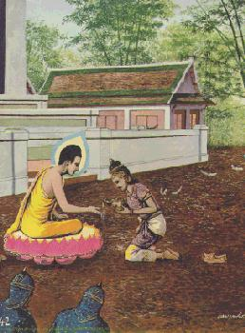

**King Bimbisara offering Veluvana the first monastery to the Buddha [26]**

# The First Monastery in Rājagaha: A Royal Offering

After offering a grand meal to the Buddha and his disciples, King Bimbisāra reflected deeply on how he could best support the Buddha’s dispensation. Understanding the need for a peaceful dwelling place where the Blessed One and his Saṅgha could reside and teach undisturbed, he searched for a suitable location not far from his palace. His eyes fell upon his royal park, *Veḷuvana*—the Bamboo Grove—a serene retreat, abundant with shade, tranquillity, and natural beauty.[27]

Determined to make this noble offering, the king performed a traditional water ceremony, a sacred act of dedication. Holding a golden ceremonial vessel, he poured water upon the Buddha’s hands and solemnly declared:

“I give this park, the Bamboo Grove, to the Saṅgha of monks, headed by the Buddha.”  
*(Etāhaṃ Bhante Veḷuvanaṃ Uyyānaṃ Buddhappamukhassa Bhikkhusaṅghassa dammi.)*

The Blessed One, accepting the offering, responded with a simple yet momentous declaration:

“I allow monasteries.”*[28]*

With these words, **the first monastery in Buddhist history was established**—*Veḷuvana Vihāra*, the Bamboo Grove Monastery, marking a pivotal moment in the Buddha’s mission.

### A Sacred Tradition of Dedication

This act of pouring water during an offering was a customary practice in ancient India, signifying the transfer of ownership with a pure heart and unwavering intention. The same ritual continues to this day in Theravāda Buddhist countries such as Sri Lanka and Thailand, where monasteries and temples are formally offered to the monastic Saṅgha, and merit is dedicated to departed relatives through similar ceremonies [29]. The tradition serves as a profound reminder of the enduring generosity of the laity in upholding and protecting the Buddha’s teachings.

### A Turning Point in the Vinaya

During this period, significant developments in the monastic discipline (*Vinaya*) took place. At the request of King Bimbisāra, the Buddha established an essential practice for the Saṅgha—the observance of *Uposatha* (the fortnightly assembly on the 8th, 14th, and 15th lunar days). On these days, the monks would gather to recite the *Pātimokkha* (the monastic code of discipline) and offer Dhamma teachings to the lay community. This marked the beginning of a structured system of monastic observance, ensuring the purity and unity of the Saṅgha. [30]

### A Legacy of Generosity and Wisdom

King Bimbisāra’s offering of Veḷuvana was more than a gift of land—it was a timeless act of devotion that provided a refuge for the Dhamma to flourish. His deep faith and wisdom in supporting the Buddha’s mission set a precedent for future generations, demonstrating how a righteous leader could contribute to the well-being of countless beings.

From this sacred ground, the Buddha would continue to teach, transforming lives with the wisdom of the Dhamma. Veḷuvana became not only the first monastery but also a symbol of the harmonious relationship between the Saṅgha and the laity—a relationship built upon generosity, virtue, and the shared aspiration for liberation.

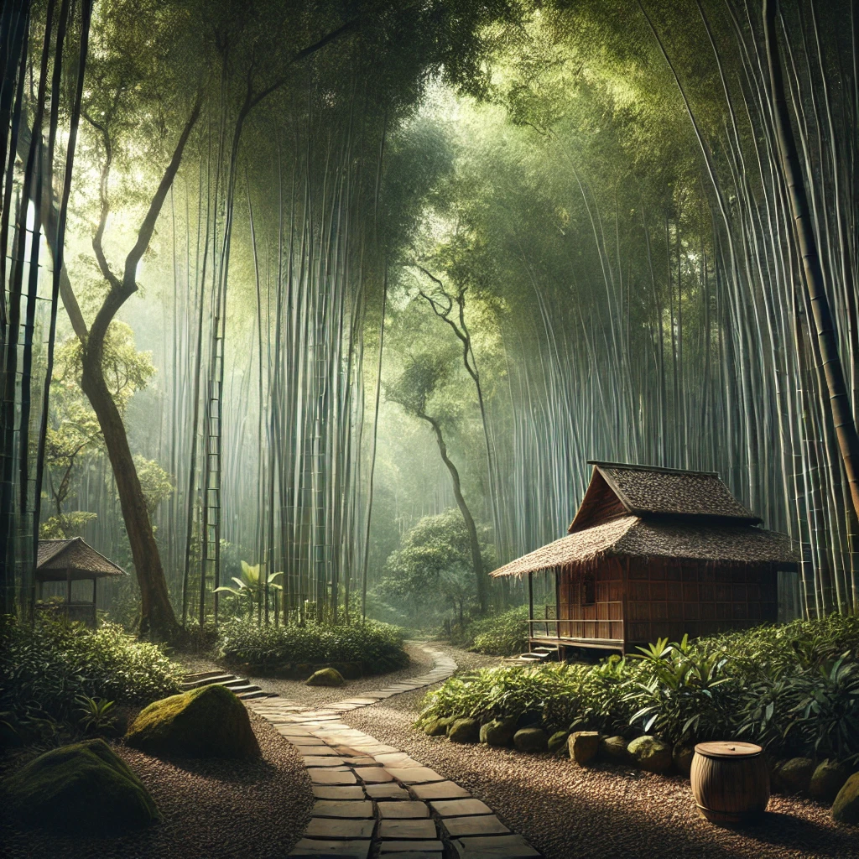

**Beautiful Veluvanaya- Bamboo Grove—the first monastery offered to the Buddha and the Sangha [31]**

### Insights from Other Sources on the Offering of Veluvana

As mentioned in the introduction to this series (Section 13), we have drawn from additional sources to provide a fuller account of significant events that took place during this period. The *Vinaya Piṭaka* records: *[32]*

*“The Buddha accepted the park. After instructing, inspiring, and gladdening the king with a teaching, he got up from his seat and left.”*

However, the *Vinaya Piṭaka* does not specify the content of the discourse given on this occasion. To bridge this gap, we refer to another source, which offers a profound teaching on the merit of offering monasteries to the Saṅgha:

### The Merit of Offering Monasteries

On the occasion of King Bimbisāra’s offering of the Bamboo Grove (*Veluvana*) to the Buddha’s dispensation, the Blessed One expounded:

*“Great King! One who builds and generously offers a monastery as a dwelling place for the community of bhikkhus bestows upon them the boon of longevity, good health, happiness, strength, and admirable wisdom.”* [33]

*A monastery provides shelter from dangers such as extreme heat and cold, preserving the well-being of its residents. Thus, the donor of such a refuge is praised by the wise as one who offers the gift of life itself.*

*Therefore, one who makes such an offering can be assured—without the slightest doubt—of happiness in both mind and body, not only in this life but also in future existences.”*

Having thus blessed King Bimbisāra with these words, the Buddha arose from his seat. Accompanied by a retinue of one thousand bhikkhus, he proceeded to Veluvana, where he took up residence.

### Additional Insights and Legends

**A Sacred Moment in History** –

According to legend: [34]

* as King Bimbisāra poured water from a golden vessel over the Buddha’s hand—following the customary ritual of dedication—the earth itself trembled. It is said that nature rejoiced, for this marked the firm establishment of the Blessed One’s dispensation in the world.
* **The First Vinaya Rule on Monastery Donations** – It was on this occasion that the Buddha established the first *Vinaya* rule permitting the Saṅgha to accept monasteries as dwellings. [35]
* **Why Veluvana is Called Kalandakanivāpa** – The monastery became known as *Kalandakanivāpa* (“Feeding Place of Squirrels”) because it was home to many squirrels, who were often seen in the area.
* **Who Was Present at Veluvana?** – The scriptures recount that when the Buddha first resided in Veluvana, he was accompanied by Venerable Uruvela Kassapa and his group of one thousand monks. At this time, Venerable Sāriputta and Venerable Moggallāna had not yet joined the Saṅgha. However, Venerable Assaji, one of the first five disciples, was present in Rājagaha. It is likely that the group of five bhikkhus who had first heard the Dhamma at Isipatana later travelled to Rājagaha as part of the early missionary efforts to spread the Buddha’s teachings.

This momentous event not only secured a permanent dwelling for the Buddha and his followers but also set a precedent for the great tradition of monastery offerings, a practice that continues to bring immeasurable merit to this day.

## The Tirokuṭṭa Sutta: The Importance of Sharing Merit with Departed Relatives

The following account, drawn from another source, provides insight into the circumstances that led the Blessed One to deliver the *Tirokuṭṭa Sutta* [36]and highlights the significance of transferring merit to departed relatives. [37]

### The King’s Dream and the Hungry Ghosts

After King Bimbisāra dedicated Veluvana Monastery to the Buddha and the Saṅgha, he accumulated immense merit. Unknown to him, however, his departed relatives—now reborn as *Petas* (hungry ghosts) [38]—had gathered in the unseen realm, hoping to receive a share of his merit. Having wandered in *saṃsāra* for a long time, they remained in a state of suffering, longing for their living relative to dedicate merit on their behalf.

Since they had not received any offerings, they appeared in the King’s dream that night, their presence terrifying him. Deeply disturbed, the King sought the guidance of the Blessed One, recounting his fearful vision. With his divine eye, the Buddha perceived the suffering of these beings and explained that their long existence in the ghostly realm was due to the absence of transferred merit from their relatives. He then advised the King to dedicate merit on their behalf.

### The King’s Offering and the Rejoicing of the Petas

Following the Buddha’s instruction, King Bimbisāra arranged a great *dāna*, offering food and requisites to the Buddha and the Saṅgha. As he poured water over the Buddha’s hands—a symbolic act of dedication—he solemnly declared:

"Idaṃ me ñātinaṃ hotu"  
*"May this merit be for the well-being of my departed relatives."*

The moment the King shared his merits, the Petas rejoiced. Moved by compassion for the King and his ancestors, the Blessed One made an aspiration, allowing the King to witness his former relatives attaining better existences and enjoying their new lives as a result of the dedicated merit.

The Buddha then delivered the *Tirokuṭṭa Sutta*, emphasizing the importance of sharing merits with departed relatives:

"Outside the walls they stand and wait,  
at the junctions and the crossroads.  
Returning to their former homes,  
they wait beside the doorposts.

But when lavish food and drink of many kinds are set out,  
no one remembers them at all,  
because of those beings’ deeds.

That’s why those who have compassion  
give to their relatives’ food and drink at the right time—  
clean, delicious, and suitable.

Just as rivers replenish the ocean,  
so too does what is given here aid the departed ones.

Neither tears, nor grief, nor lamentations  
are of any use to the departed.

But when an offering is made in the Saṅgha’s name,  
it brings lasting benefit and aids them immediately.

This is the duty of the living:  
to honour departed relatives,  
to support the mendicants,  
and in doing so, to generate great merit." [39]

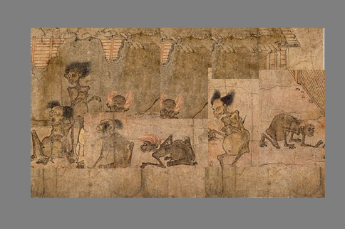

**The Hungry Ghosts - Outside the walls they stand and wait [40]**

### The Lasting Impact of the Teaching

This is the first recorded occasion in the scriptures where the Buddha explicitly highlighted the significance of dedicating merit to departed relatives. Such acts not only benefit those in the *peta* realm but also bring blessings to the donors themselves. In later discourses, the Buddha elaborated further on this practice. [41]

Another source states that at the conclusion of the *Tirokuṭṭa Sutta*, 84,000 sentient beings became keenly aware of the grave dangers of rebirth in the *peta* realm. [42]

The Buddha’s vivid description of their suffering stirred within them a sense of spiritual urgency (*saṃvega*), prompting them to diligently practice the Dhamma. As a result, many attained insights into the Noble Truths and achieved liberation.

Thus, the *Tirokuṭṭa Sutta* stands as a timeless reminder of the power of generosity, the responsibility of the living towards their departed loved ones, and the immense merit generated by such compassionate acts.

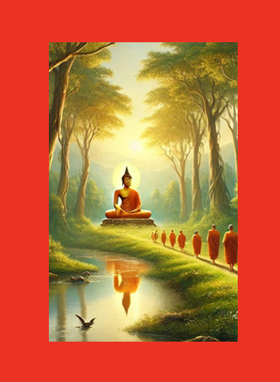

**The Buddha sitting in the beautiful forest grove in Jetavana Monastery [43]**

# Significant Events at Veluvana Monastery in Rājagaha

During this period, the Blessed One resided at Veluvana Monastery in Rājagaha, surrounded by a large community of bhikkhus, supported by King Bimbisāra and devoted lay followers of the Magadha kingdom. By the time the two chief disciples—Sāriputta and Moggallāna—joined the Saṅgha, Veluvana had already become a thriving centre of Dhamma activities, where new monks were trained and teachings were given to both the monastic and lay communities.

One source suggests that at this point, the Buddha had been in Rājagaha for approximately half a month. [44]

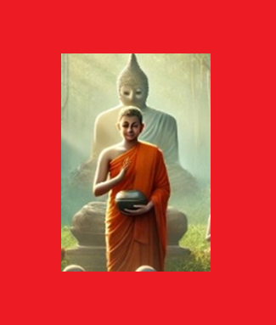

**Venerable Assaji uttering his famous verse of the teaching of his Gret Teacher [45]**

## The Arrival of Sāriputta and Moggallāna—The Two Chief Disciples

Among the many significant events that took place at Veluvana, one of the most momentous was the arrival of the two noble ones, Sāriputta and Moggallāna—formerly known as the wanderers Upatissa and Kolitha—who would go on to become the Blessed One’s *right-hand and left-hand* disciples. [46]

At the time, these two seekers were disciples of the wandering ascetic Sañjaya Belaṭṭhiputta, [47] living near Rājagaha. However, their search for the ultimate truth remained unfulfilled.

One day, while walking through the streets of Rājagaha, Upatissa encountered Venerable Assaji, one of the Buddha’s first five disciples. [48]

Observing Venerable Assaji’s serene and dignified demeanour, Upatissa thought to himself:

**“**This monk is one of those in the world who are either perfected or on the path to perfection. Why not approach him and ask about his teacher and his doctrine?” *[49]*

Approaching respectfully, Upatissa said:

**“***Venerable sir, your senses are calm, and your countenance is pure and radiant. In whose name have you gone forth? Who is your teacher, and what is the teaching you follow?”*

Venerable Assaji humbly replied:

*“There is a great ascetic, a Sakyan who has gone forth from the Sakyan clan. I have gone forth in his name. He is my teacher, and I follow his doctrine.”*

Hearing this, Upatissa’s heart leapt with excitement, and he eagerly asked to learn more about this great ascetic’s teachings. However, Venerable Assaji, demonstrating the humility characteristic of enlightened beings, said:

*“I have only recently gone forth and am still new to this path. I cannot expound the Teaching in full, but I can give you its essence in brief.”*

Knowing that a wise person needs only a few words to grasp deep truths, Upatissa urged him to share whatever he could.

**Venerable Assaji then uttered a verse that would become immortal in the annals of Buddhist history:**

“Of all things that arise from a cause,  
The Tathāgata has declared their cause,  
And also their cessation—  
Such is the teaching of the Great Ascetic.”

(*Ye dhammā hetuppabhavā, tesam hetum Tathāgato āha,  
tesañca yo nirodho, evaṁvādī Mahāsamaṇo.*)

In that instant, Upatissa realized the profound truth—**all phenomena that arise must also cease**. With the opening of the Dhamma-eye (*dhamma-cakkhu*), he attained stream-entry (*sotāpatti*).

Overcome with joy, he reflected:

**“Now this is the truth, even just this much—  
The sorrowless state that you have penetrated,  
Unseen and neglected for countless eons.”**

Without delay, Upatissa hurried to share this extraordinary realization with his closest friend, Kolitha.

### Kolitha’s Awakening and the Decision to Follow the Buddha

When Kolitha saw Upatissa approaching, he immediately noticed a transformation:[50]

*“Your senses are clear, and your complexion is radiant. Have you attained the deathless?”*

Upatissa replied with certainty:

*“I have.”*

He then recounted his encounter with Venerable Assaji and repeated the verse that had unlocked the truth for him. As soon as Kolitha heard it, he too attained stream-entry.

Thus, through the power of *kalyāṇa-mittatā*—the association of good and noble friends—the door to the end of *saṃsāra* opened for Kolitha.

Together, they went to their teacher Sañjaya and informed him that they had found the true Teacher, the Buddha. They requested to leave him, along with their 250 fellow students, to seek full ordination under the Blessed One. Overcome by frustration at losing his foremost disciples, Sañjaya refused to join them. The sources recount that, in his intense agitation, he vomited hot blood on the spot.[51]

With unwavering resolve, Upatissa and Kolitha led their followers to the Bamboo Grove (*Veluvana*), where the Blessed One resided. As they approached, the Buddha foresaw their arrival and spoke to the Saṅgha:

*“These two friends are coming—Kolitha and Upatissa.  
They will be an excellent pair,  
My most eminent disciples.”[52]*

Upon reaching the Buddha, the two bowed at his feet and requested ordination:

“Sir, we wish to go forth in your presence.  
We wish to receive full ordination.”

The Blessed One, with his profound compassion, simply said:

“Come, monks. The Teaching is well-proclaimed.  
Practice the spiritual life to make a complete end of suffering.”

With these words, Upatissa and Kolitha were instantly ordained as bhikkhus in the Saṅgha—receiving the names *Sāriputta* and *Moggallāna*, respectively.

From that day forward, these two noble ones, through their extraordinary wisdom and diligence, would become pillars of the Dhamma, guiding both monastics and lay disciples alike.

### Legacy of Their Ordination

* This occasion marked the beginning of the Buddha’s two chief disciples’ journey in spreading and preserving the Dhamma. Their profound knowledge and skilful teaching significantly contributed to the establishment of the Saṅgha.
* One source suggests that the first meeting between the Buddha and the two future chief disciples took place around the *Māgha* season (January–February). [53]
* The ordination of Sāriputta and Moggallāna was a turning point in Buddhist history—strengthening the Saṅgha with disciples of extraordinary wisdom (*paññā*) and meditative mastery (*samādhi*).

Thus, Veluvana Monastery, once a simple royal park, became the sacred ground where the seeds of the Buddha’s dispensation (*sāsana*) flourished—nurturing not only individual liberation but the collective welfare of all beings.

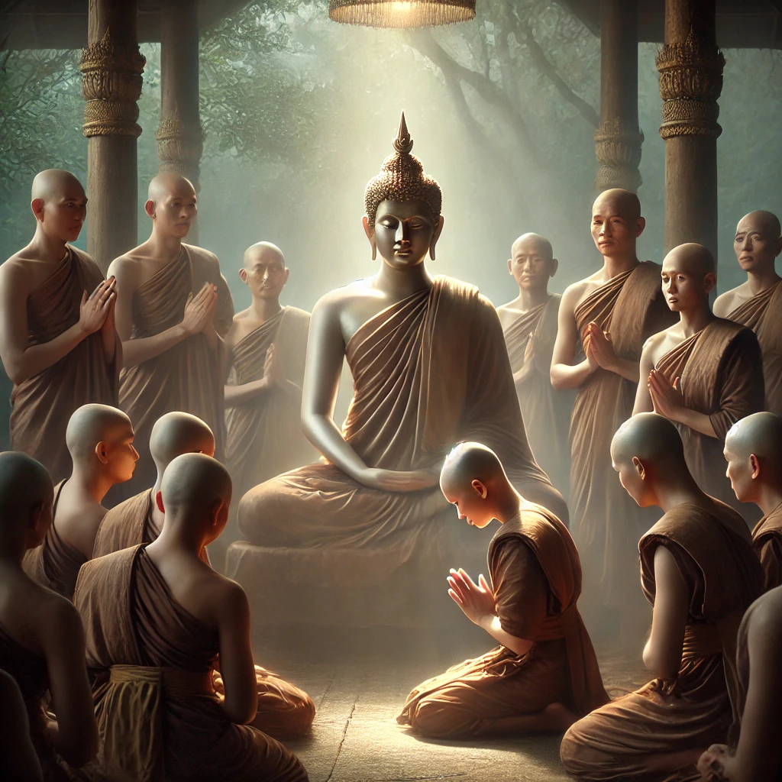

**Ordination of Sāriputta and Moggallāna was a turning point in Buddhist history—strengthening the Saṅgha with disciples of extraordinary wisdom (*paññā*) and meditative mastery-supernormal powers (*iddhividha)* [54]**

## Venerable Sāriputta and Venerable Moggallāna Attain Arahantship

The scriptures recount the profound spiritual journeys of the two chief disciples—Venerable Moggallāna and Venerable Sāriputta—culminating in their attainment of final liberation (*arahantship*). Among them, Venerable Moggallāna was the first to reach this supreme realization.

### Venerable Moggallāna’s Struggle and Triumph

Venerable Moggallāna, gifted with immense meditative potential, attained arahantship merely one week after his ordination. Immediately after becoming a bhikkhu, he withdrew to a quiet village called Kallavālamuttagāma in the Magadha region to dedicate himself to deep meditation. [55]

However, for seven days, he struggled tirelessly, yet he found himself overwhelmed by fatigue and drowsiness, unable to continue his practice.

At that moment, through his divine vision, the Blessed One beheld the struggle of his noble disciple. Moved by boundless compassion, he appeared before Venerable Moggallāna and offered him guidance, showing him the way to overcome drowsiness and refine his meditation: [56]

**“Moggallāna, do not be negligent, brahmin, regarding the fourth jhāna.**  
**Steady your mind in the fourth jhāna, unify your mind in the fourth jhāna,**  
**Concentrate your mind in the fourth jhāna.”**

Following the Blessed One’s profound instructions, Venerable Moggallāna entered the deeper absorptions and broke through all remaining defilements. With unshakable wisdom, he realized the ultimate truth and attained *arahantship*.

Later, reflecting on his journey, Venerable Moggallāna addressed the Bhikkhu Saṅgha with gratitude: [57]

**“If one were to rightly say of anyone,**  
**‘This is a disciple who attained to greatness of direct knowledge with the assistance of the Teacher,’**  
**it is of me that one could rightly say this.”**

Through the Buddha’s compassionate guidance and his own perseverance, Venerable Moggallāna mastered the four jhānas, the four formless attainments, and the profound *signless concentration* (*animitta samādhi*). **He became foremost in supernormal powers (*****iddhividha*),** *[58]*using his extraordinary abilities for the benefit of the Saṅgha and countless beings.

## Venerable Sāriputta’s Path to Arahantship

Venerable Sāriputta, the foremost disciple in wisdom, attained arahantship two weeks after his ordination. His final realization took place in a most remarkable setting—while listening to a discourse of the Buddha, not for himself, but delivered to another seeker.

According to the *Dīghanakha Sutta* (MN: 74), the Buddha was giving a discourse to Brahmin Dīghanakha—Venerable Sāriputta’s nephew—at the Boar’s Cave on Vulture Peak in Rājagaha. As the Buddha expounded the Dhamma, guiding Dīghanakha towards right view, Venerable Sāriputta, who stood by listening attentively, penetrated the ultimate truth.

At that moment, his mind was completely liberated from all defilements—he became an *arahant*. Simultaneously, his nephew, Brahmin Dīghanakha, attained *stream-entry* (*sotāpatti*). [59]

## The Legacy of the Two Chief Disciples

Thus, within weeks of their ordination, the two noble ones—Sāriputta and Moggallāna—fulfilled their spiritual quests, attaining the highest liberation. Their unparalleled wisdom and meditative mastery would go on to illuminate the Saṅgha, strengthening the Buddha’s dispensation for generations to come.

* **Venerable Moggallāna**, through unwavering diligence, overcame all obstacles and became the foremost disciple in supernormal powers, using his abilities to safeguard and uphold the Dhamma.
* **Venerable Sāriputta**, with his supreme wisdom, became the chief expounder of the Buddha’s teachings, guiding innumerable disciples on the path to liberation.

Their lives stand as a testament to the power of the Dhamma and the boundless compassion of the Blessed One—who, seeing the potential in noble beings, nurtured them to full awakening.

# The Buddha Receiving Both Praise and Blame in Magadha

In the teachings of the Blessed One, the *Eight Worldly Conditions* [60] (*Aṭṭha Loka Dhamma*) describe the ever-changing nature of worldly experiences—gain and loss, fame and disgrace, praise and blame, pleasure and pain. While ordinary beings become elated by praise and distressed by criticism, the Buddha and the noble ones remained unmoved by either.

The *Vinaya Piṭaka* records incidents during the Buddha’s stay in Rājagaha that illustrate this truth.

### Praise from the King of Devas

Earlier, we saw how Sakka, the King of Devas, came to Rājagaha to express his profound reverence for the Buddha. Recognizing the Blessed One’s supreme wisdom and boundless compassion, Sakka praised him as the teacher of both gods and humans.

### Criticism from the People of Magadha

At the same time, as the Buddha compassionately preached the Dhamma in Rājagaha, many young men of Magadha—some from well-known families—renounced the household life and became monastics. Witnessing this, certain people in the city began to grumble, blaming the Buddha for causing disruption in their society: [61]

**“***The ascetic Gotama is making us childless! He’s making us widows!  
He’s breaking up good families! A thousand dreadlocked ascetics have gone forth because of him, and now another two hundred and fifty disciples of Sañjaya have also left their homes!”*

When the monks reported this to the Blessed One, he responded with unwavering serenity. Instead of reacting with resentment, he instructed them to recite the following verse if they encountered such complaints:

**“Indeed, the Great Heroes, the Buddhas,**  
**Lead by means of a good teaching.**  
**When you understand this, what indignation can there be**  
**Toward those who lead legitimately?”** [62]

Upon hearing this, the people of Magadha gradually understood that the Sakyan monastics had renounced the world in a noble and rightful manner. Their complaints subsided, and they came to respect the path of renunciation.

### The Buddha’s Unshakable Equanimity

Through this episode, the Blessed One demonstrated that praise and blame are merely part of the ever-changing nature of the world. While some praised his wisdom and compassion, others criticized him out of attachment and misunderstanding. Yet, the Buddha remained unshaken, guiding beings with patience and wisdom.

Thus, the words of the Great Sage remind us:

**“Just as a solid rock remains unmoved by the wind,**  
**so too, the wise remain unshaken by praise or blame.”[63]**

## Jīvaka Komārabhacca – The Esteemed Physician

According to the *Vinaya Piṭaka*, King Bimbisāra, recognizing the exceptional skills of Jīvaka Komārabhacca, **[64]** appointed him as the royal physician and entrusted him with the care of the Buddha and the Sangha. The king addressed Jīvaka with these words:

**“***Well then, Jīvaka, please attend on me, the harem, and the Sangha of monks headed by the Buddha.” [65]*

Jīvaka not only served as the physician of the Blessed One but also became a devoted disciple, attaining the noble state of stream-entry. The Buddha spoke of his spiritual attainment, declaring:

*“Bhikkhus, possessing six qualities… Jīvaka Komārabhacca has reached certainty about the Tathāgata and become a seer of the deathless, one who lives having realized the deathless.  
What six? Unwavering confidence in the Buddha, unwavering confidence in the Dhamma, unwavering confidence in the Saṅgha, noble virtuous conduct, noble knowledge, and noble liberation.”* *[66]*

Among all lay followers, the Blessed One declared Jīvaka to be foremost in his deep personal confidence in the Buddha. [67]

# Profound Teachings Delivered in Magadha

With the establishment of Veluvana Monastery, the Buddha delivered many profound teachings in Magadha. Some of the key insights from these discourses are as follows:

## Nothing in the World is Worth Clinging To

One of the most transformative teachings was given to Venerable Mahā Moggallāna, guiding him toward full liberation. The Blessed One revealed that true freedom from suffering comes from relinquishing attachment to all worldly things:

“Here, Moggallāna, a bhikkhu has heard: ‘Nothing is worth holding to.’  
When a bhikkhu has heard: ‘Nothing is worth holding to,’ he directly knows all things.  
Having directly known all things, he fully understands all things.  
Having fully understood all things, whatever feeling he feels—pleasant, painful, or neutral—  
he contemplates its impermanence, its fading away, its cessation, and its relinquishment.  
As he dwells contemplating thus, he does not cling to anything in the world.  
Not clinging, he is not agitated. Being unagitated, he personally attains Nibbāna.  
He understands: ‘Destroyed is birth; the spiritual life has been lived; what had to be done has been done; there is no more coming back to any state of being.’”  *[68]*

This teaching encapsulates the essence of the path to liberation—letting go of attachment to everything impermanent.

## Overcoming Drowsiness in Meditation

Venerable Moggallāna, during his meditation practice, struggled with drowsiness. The Buddha compassionately instructed him on seven practical methods to overcome it: [69]

1. Change the focus – Shift attention from the meditation object if it induces drowsiness.
2. Reflect on the Dhamma – Contemplate the teachings that have been learned.
3. Recite aloud – If drowsiness persists, reciting a sutta helps refocus the mind.
4. Physical stimulation – Pulling the ears and rubbing the limbs can awaken the senses.
5. Refresh the senses – Washing the face, surveying the surroundings, and gazing at the sky dispels dullness.
6. Perception of Light – Meditate on brightness, cultivating a luminous mind.
7. Walking Meditation – Walk back and forth with mindfulness, keeping awareness of both front and back.

If drowsiness remains despite these efforts, the Buddha advised lying down mindfully with the determination to rise promptly, without indulging in the pleasure of sleep.

## The Path to Jhānas and Immaterial States

In the *Moggallāna Saṁyutta* (SN 40), nine discourses describe the Buddha’s guidance to Venerable Moggallāna in developing deep samādh*i* [70]

* **Regarding the Four Jhānas** – The Buddha repeatedly instructed:

“Moggallāna, do not be negligent regarding the first jhāna… the second jhāna… the third jhāna… the fourth jhāna.  
Steady your mind, unify your mind, concentrate your mind in these meditative absorptions.”

* Regarding the **Four Immaterial Attainments** – The Buddha further advised:

“Moggallāna, do not neglect the base of the infinity of space, the base of the infinity of consciousness, the base of nothingness, and the base of neither-perception-nor-nonperception.  
Steady your mind, unify your mind, concentrate your mind in these attainments.”

* Regarding **the Sign-less** *samādhi* (*Animitta Ceto-samādhi*) – The Buddha emphasized:

“Moggallāna, do not be negligent regarding the sign-less concentration of mind.  
Steady your mind, unify your mind, concentrate your mind in this profound state.”

Through these instructions, the Blessed One revealed the step-by-step progression towards the highest liberation.

## The Impermanence of the Body and Feelings

Another profound discourse was delivered to the Brahmin Dīghanakha, who was Venerable Sāriputta’s nephew. This discourse, given at the Boar’s Cave on Vulture Peak, resulted in Dīghanakha attaining stream-entry and Venerable Sāriputta realizing arahantship. *[71]*

The Buddha taught:

*“The body should be regarded as impermanent, as suffering, as a disease, as a tumour, as a dart, as a calamity, as an affliction, as alien, as disintegrating, as void, as not-self.  
When one regards the body thus, one abandons desire for the body*.”

Furthermore, the Buddha explained the nature of feelings:

*“There are three kinds of feeling: pleasant, painful, and neither-painful-nor-pleasant.  
All feelings are impermanent, conditioned, dependently arisen, and subject to cessation.”*

Upon truly understanding this, a well-instructed disciple becomes disenchanted with feelings and abandons attachment. As a result, the mind becomes liberated, and with that liberation comes the realization:

*“Birth is destroyed, the holy life has been lived, what had to be done has been done, there is no more coming to any state of being.”*

## The Path of the Noble Ones

Through these teachings, the Blessed One illuminated the path to liberation—one that transcends worldly attachments, overcomes hindrances, and cultivates profound wisdom. The stories of Jīvaka Komārabhacca, Venerable Moggallāna, and Venerable Sāriputta serve as shining examples of unwavering faith, perseverance, and ultimate realization.

The words of the Buddha remain timeless

**“**Nothing is worth holding to.”

“Steady your mind in the jhānas, unify your mind, concentrate your mind.”

“The wise, seeing impermanence, abandon clinging and attain Nibbāna.”

May all beings walk this noble path toward true liberation!

# More Illustrious Disciples Joining the Sangha from Magadha

During this period, several renowned disciples entered the monastic order, enriching the Sangha with their wisdom and dedication. Among them, the following events stand out as remarkable milestones in the history of the Dispensation.

The Ordination of Venerable Rādha [72]

According to the *Vinaya Pitaka*, [73] before his ordination, Rādha was an elderly Brahmin from Rājagaha. On one occasion, he humbly requested to become a monk, but the bhikkhus hesitated to accept him. When the Buddha learned of this, he inquired whether any among the Sangha remembered a good service rendered by the old Brahmin. Venerable Sāriputta then recalled a simple yet significant act—Rādha had once given him a spoonful of rice. Upon hearing this, the Buddha granted him permission for ordination, and Venerable Sāriputta became his preceptor.

Despite his advanced age, Venerable Rādha practiced diligently under his teacher’s guidance. With unwavering effort, he soon attained arahantship, [74] demonstrating that spiritual liberation is not bound by age but by dedication and right effort.

* On this occasion, the Buddha extolled the virtue of **gratitude**, declaring that it is a hallmark of the **superior person (sappurisa)**—one who recognizes and appreciates kindness.
* According to another source, after Rādha’s ordination, Venerable Sāriputta took him to a quiet forest dwelling, sharing with him his four requisites. With proper care and support, the elderly monk regained his health, enabling him to practice with vigor. [75] Before long, his perseverance bore fruit, and he attained the supreme bliss of liberation.

## Venerable Mahākassapa’s Encounter with the Buddha

Another momentous event of this period was the ordination of Venerable Mahākassapa, one of the most eminent disciples of the Buddha. **[76]**

Born into a wealthy Brahmin family in Mahātittha, Magadha, [77] even before the birth of the Blessed One, he had a deep inclination toward renunciation. Realizing the suffering inherent in household life, he renounced the world in search of the truth.

Mahākassapa described his first encounter with the Buddha with profound reverence:

**“… As I wandered on my spiritual quest, I saw the Blessed One seated by the Bahuputta Shrine, between Rājagaha and Nālandā. Upon seeing him, a certainty arose within me: ‘If ever I were to meet a true Teacher, it would be this Blessed One himself. If ever I were to see a Perfectly Enlightened One, it would be this very Master.’ Filled with devotion, I prostrated at his feet and declared: ‘Venerable sir, the Blessed One is my teacher, and I am his disciple.’”** [78]

Recognizing Mahākassapa’s sincerity, the Buddha accepted him into the monastic order and imparted a profound teaching:

### The Importance of Listening to the Dhamma with an Open Heart

*“Kassapa, you should train yourself thus: ‘Whenever I listen to any teaching that is wholesome, I will listen with eager ears, regarding it as a matter of vital importance, applying my whole mind to it. I will never abandon mindfulness of the body that is associated with joy.’”[79]*

* Inspired by these words, Venerable Mahākassapa diligently practiced meditation. By the seventh day, his unwavering effort bore fruit—he realized **arahantship**, fully liberated from all defilements.
* On this occasion, the Buddha, recognizing Mahākassapa’s ascetic virtue, exchanged robes with him, signifying the deep spiritual bond between teacher and disciple.

Venerable Mahākassapa and the First Buddhist Council **[80]**

After the Parinibbāna of the Blessed One, Venerable Mahākassapa emerged as a steadfast guardian of the Dhamma. His leadership was crucial in preserving the teachings for future generations.

As recorded in the *Vinaya Pitaka*, Mahākassapa was traveling from Pāvā to Kusinārā with a retinue of five hundred monks when he encountered a group of Ājīvakas carrying coral-tree flowers. He inquired about the Blessed One’s whereabouts, and they sorrowfully informed him that the Buddha had passed into final **Parinibbāna** seven days earlier. [81]

Upon hearing this, the noble disciples accepted the truth with equanimity, understanding the impermanent nature of all conditioned things. However, some monks, overwhelmed with grief, wept inconsolably. Among them was Subhadda, an elderly monk, who responded with shocking irreverence:

*“Why grieve? Why lament? We are now free of that great ascetic! We were constantly restrained by his teachings—always told what is allowed and what is not. Now, at last, we can do as we please!”*

These words pierced Mahākassapa’s heart. Recognizing the urgent need to protect the integrity of the Dhamma and the Vinaya, he called upon the Sangha, saying:

“Let us come together to recite the **Dhamma** and the **Monastic Discipline**, before corruption sets in. Let us do so before false teachings overshadow the true Dhamma, before those who distort the path become strong and those who uphold it become weak.” *[82]*

Thus, under his leadership, **the First Buddhist Council**—a great communal recitation—was convened at Rājagaha. Five hundred fully enlightened arahants gathered to codify and preserve the Buddha’s teachings in their pristine form.

In recognition of his wisdom and unwavering commitment, Mahākassapa became the **de facto head of the Sangha**, entrusted with the noble duty of upholding the Buddha’s legacy.

As the scriptures proclaim:

**“With the holding of the First Council, the great esteem in which Mahākassapa was held grew even greater. He stood as a beacon of wisdom, an embodiment of the true disciple, and a guardian of the Dispensation.”** *[83]*

# The Presence of More Eminent Disciples

### Venerable Upasena Vaṅgantaputta: An Exemplar of Confidence and Spiritual Strength

During this period, Venerable Upasena Vaṅgantaputta **[84]** was present in Rājagaha, earning recognition for his serene and inspiring presence. He was the younger brother of the great Venerable Sāriputta and is believed to have been ordained in his hometown, Nalaka, in the region of Magadha.

One account state that after becoming a bhikkhu, Venerable Sāriputta returned to Nalaka and ordained his siblings, [85] including Venerable Upasena. By the time he had an audience with the Blessed One, he had already spent two years in the monastic life. [86]

Recognizing his unwavering confidence and the faith he instilled in others; the Buddha declared him **foremost among those who inspire confidence in all respects** (*sabbathā-gāha-vissāsakānaṃ*). [87]

Venerable Upasena rejoiced deeply in the rare fortune of being a disciple of the Buddha, expressing his gratitude in this way:

*“It is indeed a great gain for me, a most excellent gain, that my teacher is the Perfectly Enlightened One. I have gone forth into the noble path in such a well-proclaimed Dhamma and Discipline. My companions in the holy life are virtuous, possessing noble qualities. I have fulfilled the precepts, my mind is composed, and I have attained single-pointed concentration. Now, I am an Arahant, free from all defilements, endowed with great power and majesty. My life has been truly fortunate, and even in death, I will be free from sorrow.” [88]*

Perceiving Venerable Upasena’s reflection through his divine mind, the Buddha uttered these profound verses:

*“One who is unshaken by life’s adversities,*

*who remains free from sorrow at the end in death—*  
*Such a one, firm in wisdom, has realized the state of peace.*  
*Amidst the world’s grief, he does not grieve.*

*For the monk who has severed craving, whose mind rests in stillness,*  
*Having completely destroyed the cycle of rebirth,*  
*There is no further becoming.”*

Through this, the Buddha affirmed the unshakable equanimity of one who has seen the truth—free from fear, lamentation, and sorrow.

### Venerable Dabba Mallaputta: A Child Arahant of Great Service

Another extraordinary disciple present in Rājagaha during this period was Venerable Dabba Mallaputta, a remarkable young monk who attained arahantship at just **seven years old**. [89]

Born in the Malla region, he received ordination at the Anupiya Mango Grove, after which he followed the Buddha and took residence at Veluvana Monastery in Rājagaha. [90]

Despite his young age, his spiritual accomplishment and organizational skills led the Buddha to entrust him with two important responsibilities:

1. **Assigning lodgings for the monks**, ensuring that members of the Sangha found suitable places to stay.
2. **Directing bhikkhus to their respective alms-food donors**, ensuring an orderly distribution of offerings.

For his extraordinary ability in managing these duties with wisdom and impartiality, the Buddha declared him foremost among those who assign lodgings for the Sangha (*sannipāta-paññattānaṃ*). [91]

Venerable Dabba Mallaputta exemplifies how **true wisdom and inner purity are not bound by age**. His life stands as a testament to the power of virtue, mindfulness, and right effort in transcending worldly limitations.

# The Buddha’s Fourth Walking Tour

## The Blessed One’s Return to Kapilavattu

A significant event during this period was the long-awaited return of the Blessed One to his homeland, Kapilavattu, in response to an invitation from King Suddhodana.

Since his departure at the age of twenty-nine (see: section 3) to embark on his ascetic quest, the Buddha had never returned home. Now, as the Fully Enlightened One, he set forth on a historic journey to meet his family and the people of the Sakyan kingdom.

The *Vinaya Pitaka* describes his departure from Rājagaha as follows:

*“…After staying in Rājagaha for as long as he wished, the Buddha set out on his wandering journey toward Kapilavattu in the Sakyan country. Upon arrival, he resided at the Banyan Tree Monastery (Nigrodhārāma).”* [92]

# King Suddhodana’s Invitation and Kāludāyi’s Mission

Upon hearing that the Buddha was residing at Veluvana Monastery, King Suddhodana, eager to see his son once more, sent his minister Kāludāyi to invite the Blessed One to Kapilavattu.

According to scriptures and tradition, Kāludāyi had been a close friend of Prince Siddhartha in their youth. After the prince renounced lay life, Kāludāyi entered royal service as a minister to King Suddhodana. Recognizing his deep connection with the Buddha, the king entrusted him with the important task of delivering the invitation.

Upon arriving in Rājagaha, Kāludāyi paid homage to the Buddha and listened to one of his discourses. Inspired by the Dhamma, he attained arahantship. In his *Theragāthā*, he expresses his liberation in these words:

*“I am the son of the Buddha, the incomparable Aṅgīrasa,  
The unaffected, the bearer of the unbearable.  
You, Sakya, are my father’s father;  
Gotama, you are my grandfather in the Dhamma*.” (*Thag:10.1*)

Though he had attained the highest liberation, Kāludāyi remained mindful of the mission he had undertaken in Kapilavatthu. Respectfully, he approached the Buddha and conveyed King Suddhodana’s invitation to visit his homeland. In the *Theragāthā*, he poetically encourages the Buddha to make the journey:

“*The blossoming trees are delightful,  
Wafting their scent in all directions.  
They have shed their leaves and now long to bear fruit.  
Hero, it is time to depart.  
The season is neither too hot nor too cold,  
A pleasant time for travel.  
Let the Sākyans and Koliyans see you,  
Crossing westward over the Rohiṇī River.”*

This poetic description reflects not only the natural beauty of the path but also the spiritual significance of the journey—a pilgrimage back to the roots of the Buddha’s early life.

According to tradition, [93]the Buddha took sixty days to complete the sixty-league journey from Rājagaha to Kapilavatthu. Each day, Kāludāyi traveled by air to the king’s palace to report on the Buddha’s progress. He also brought back a bowl of the finest food from the palace to offer to the Buddha. By the time the Blessed One arrived in his homeland, his kinsmen were already filled with faith in him. Because of his remarkable service, Kāludāyi was declared pre-eminent among those who bring joy to their clans (*kulappasādakānaṃ aggo*). (*AN 1:225*)

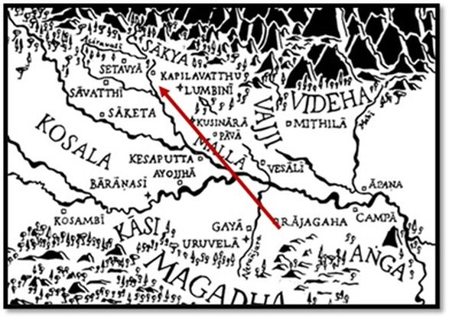

**The Route from Rājagaha to Kapilavattu [94] the Fourth Walking Tour of the Buddha**

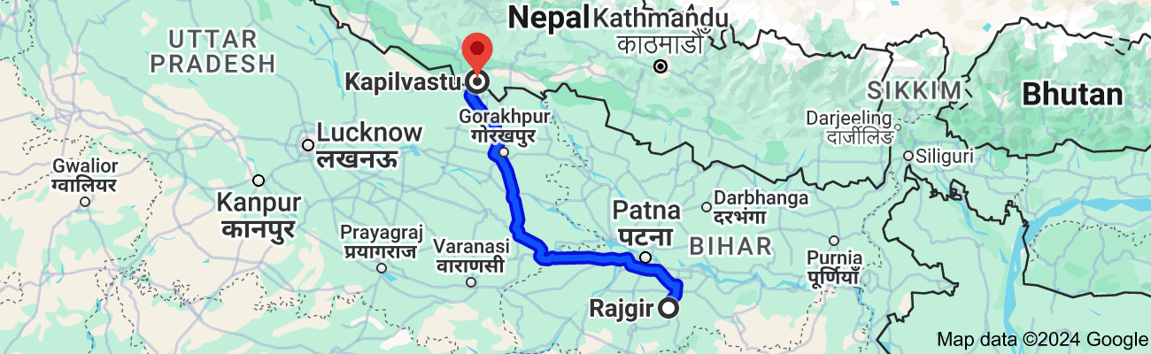

**Present day Map: Rajgir to Kapilavastu -distance about 518 km.[95]**

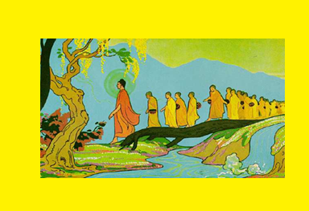

**Road to Kapilavattu- Buddha walking with his many disciples [96]**

# The Buddha’s Journey: A Noble Procession

The Buddha departed from Rājagaha in the waning moon of Phagguna (February-March), accompanied by a large Sangha of monks. Traveling at a measured pace of one yojana (approximately 16 km) per day, he planned to complete the sixty-yojana journey within two months. [97]

This **Fourth Walking Tour** was not just a homecoming but a momentous occasion that would lead to profound transformations within the royal family and the Sakyan community. It marked the beginning of new spiritual awakenings—where princes, noblemen, and even the Buddha’s own kin would embrace the path of renunciation, bringing the light of the Dhamma to Kapilavattu.

# Reflections on This Period

These events reveal the extraordinary vitality of the Buddha’s Dispensation during this time in Rājagaha. We witness the emergence of remarkable disciples, each embodying a unique aspect of the Noble Path.

Venerable Sāriputta shines with unparalleled wisdom, while Venerable Moggallāna displays meditative mastery and supernormal powers. Despite his old age, Venerable Rādha’s unwavering determination carries him to the far shore of liberation. Venerable Mahākassapa exemplifies ascetic virtue, his deep spiritual connection with the Buddha honoured through the sacred exchange of robes. Venerable Upasena stands firm in unshakable confidence. The faithful friend Kāludāyi, though newly awakened as an arahant, does not waver in his mission to bring the Blessed One to Kapilavattu. The youthful Venerable Dabba Mallaputta reveals wisdom beyond his years.

These stories continue to inspire seekers on the path, illuminating the noble qualities of faith, effort, and wisdom that lead to the highest goal—liberation. They remind us that regardless of age, background, or circumstances, the path is open to all who strive with sincerity.

With this reflection, we conclude this section. The next section (14-2) will focus on the events that unfolded in Kapilavatthu during the Buddha’s visit to his homeland.

### End Notes: Section 14-1

1. When he was an ascetic at age 29, he visited the city of Rajagaha and met King Bimbisara, see: section: 3.
2. VP: Mahākandaka 13: Monastic Law of Theravada School: Translated by Bhikkhu Brahmali .
3. Source 1: Madhuratthavilāsinī (Buddhavaṁsatthakathā) of Bhadantâcariya Buddhadatta Mahathera: Translated by I. B. Honer, 1946.
4. Source 2: Jinacaritaṁ, The Life of the Victorious Buddha, translated by Bhikkhu Anandajoti
5. Magadha was a region in ancient India, named after an ancient kingdom of the same name, which was one of the sixteen [Mahajanapadas](https://en.wikipedia.org/wiki/Mahajanapadas" \o "Mahajanapadas) during the [Second Urbanization](https://en.wikipedia.org/wiki/Second_Urbanization) period, based in the [eastern Ganges Plain](https://en.wikipedia.org/wiki/Indo-Gangetic_Plain). The region was ruled by several dynasties, which overshadowed and incorporated the other Mahajanapadas. Magadha played an important role in the development of [Jainism](https://en.wikipedia.org/wiki/Jainism) and [Buddhism](https://en.wikipedia.org/wiki/Buddhism).[[2]](https://en.wikipedia.org/wiki/Magadha#cite_note-Keown2004-2) source: Wikipedia . *This was later becoming the Empire of King Asoka, Pataliputta – was the royal capital.
6. Source: Suttacentral
7. Source: Research Gate https://www.researchgate.net/figure/Map-of-India
8. Google map.
9. Source: https://www.buddhaviews.com/Buddha_India/buddha_india292.htm
10. Ibid.
11. Chapter 15” Maha Buddhavamsa- The Great Chronicle of Buddha by Ven. Mingun Sayadaw
12. VP: Mahākandaka 13. **Note**: The king met the Buddha first time, when he was wandering in his kingdom as an ascetic, for details see: section 3.
13. “King of [Magadha](https://aimwell.org/DPPN/magadha.html) and patron of the Buddha. He ascended the throne at the age of fifteen and reigned in [Rājagaha](https://aimwell.org/DPPN/rajagaha.html) for fifty-two years… the first meeting between the Buddha and Bimbisāra took place in Rājagaha under the Paṇḍavapabbata, only after the Buddha’s Renunciation. The king, seeing the young ascetic pass below the palace windows, sent messengers after him. On learning, that he was resting after his meal, Bimbisāra followed him and offered him a place in his court. This the Buddha refused, revealing his identity. The Commentary [adds](https://aimwell.org/DPPN/bimbisara.html#04) ⁴ that Bimbisāra wished him success in his quest and asked him to visit first Rājagaha as soon as he had attained Enlightenment…Bimbisāra’s death, according to the Commentaries, was a sad [one](https://aimwell.org/DPPN/bimbisara.html#09).⁹ Soothsayers had predicted, before the birth of **Ajātasattu**, that he would bring about the death of his father, for which reason his mother had wished to bring about an abortion. However, Bimbisāra would not hear of this, and when the boy was born, treated him with the greatest [affection](https://aimwell.org/DPPN/bimbisara.html#10).¹⁰ When the prince came of age, [Devadatta](https://aimwell.org/DPPN/devadatta.html), by an exhibition of his psychic-power, won him over to his side and persuaded him to encompass the death of his father. Bimbisāra died, and was reborn in the **Cātummahārājika** world as a yakka named [Janavasabha](https://aimwell.org/DPPN/janavasabha.html), in the retinue of [Vessavaṇa](https://aimwell.org/DPPN/vessavana.html). The [Janavasabha Sutta](https://aimwell.org/DPPN/janavasabha.html" \l "JanavasabhaSutta) records an account of a visit paid by **Janavasabha** to the Buddha sometime after: Source: Dictionary of Pāli Proper Names by G.P. Malalasekera
14. VP: Mahākandaka 13.
15. Source: <https://commons.wikimedia.org/wiki/File:033_King_Bimbisara_goes_to_meet_the_Buddha>
16. VP: Mahākandaka 13.
17. Ibid.
18. VP: Mahākandaka 13.
19. Ibid.
20. Ibid.
21. https://ancient-buddhist-texts.net/English-Texts/Short-Pieces-in-Sanskrit/Fourth-Discourse.htm
22. VP: Mahākandaka 13.
23. AI generated image.
24. Sakka Deva, follower of the Buddha, became a stream winner, for details: see: SN: Sakkkasamyutta.
25. VP: Mahākandaka 13.
26. Source: Mahidol University: https://mahidol.ac.th/budsir/E_hist42.htm
27. “Veḷuvana, a park near Rājagaha, the pleasure garden of Bimbisāra… his was the first monastery *(ārāma)*accepted by the Buddha, and a rule was passed allowing monks to accept such a [park](https://aimwell.org/DPPN/veluvana.html#02).² This was the only monastery in Jambudīpa, the dedication of which was accompanied by a tremor of the earth. It was the dedication of Veḷuvana that was quoted as precedent by Mahinda, when he decided to accept the Mahāmeghavana, at [Anurādhapura](https://aimwell.org/DPPN/anuradhapura.html), from [Devānampiyatissa](https://aimwell.org/DPPN/devanampiyatissa.html). source: Dictionary of Pāli Proper Names by G.P. Malalasekera.
28. VP: Mahākandaka 13
29. See: KP: Thirokutta sutta
30. For details: see: VP: Uposathakhandaka.
31. AI generated image.
32. VP: Mahākandaka 13
33. See: Maha Buddhavamsa- The Great Chronicle of Buddhas-chapter 15 - by Ven. Mingun Sayadaw
34. Ibid. See also: * This was the only monastery in Jambudīpa, the dedication of which was accompanied by a tremor of the earth. It was the dedication of Veḷuvana that was quoted as precedent by Mahinda, when he decided to accept the Mahāmeghavana, at [Anurādhapura](https://www.aimwell.org/DPPN/anuradhapura.html), from [Devānampiyatissa](https://www.aimwell.org/DPPN/devanampiyatissa.html). Source: https://www.aimwell.org/DPPN/veluvana.html
35. This was the first monastery *(ārāma)*accepted by the Buddha, and a rule was passed allowing monks to accept such a [park](https://www.aimwell.org/DPPN/veluvana.html#02). See: VP: Mahākandaka 13
36. KN: KP: The Hungry Shades Beyond the Walls Discourse
37. Maha Buddhavamsa- The Great Chronicle of Buddhas-chapter 15- by Ven. Mingun Sayadaw
38. Peta-Hungary Ghosts is one of the lower realms, where people get reborn due to bad kamma. For details see KN: KP: Petavattu.
39. KN: KP:7 ( Tirokuṭṭasutta , translated by Bhikkhu Sujato: suttacentral * this sutta also is given in KN: Petavatthu.
40. Source: Kyoto National Museum: https://commons.wikimedia.org/wiki/File:Gaki-Zoushi.jpg
41. See: AN10:177 (Jāṇussoṇī)
42. Maha Buddhavamsa- The Great Chronicle of Buddhas-chapter 15- by Ven. Mingun Sayadaw
43. AI generated iamage.
44. Maha Buddhavamsa- The Great Chronicle of Buddhas-chapter 16- by Ven. Mingun Sayadaw
45. AI generated image.
46. VP: Mahākandaka 14. * The Buddha declared them as foremost of his disciples, see AN1” 189 & 190 * For more details see: Great Disciples of the Buddha by Bhikkgu Nyanaponika and Helmut Hecker also <https://dahampada.github.io/>
47. He was one of the 6 famous teachers lived during the time of the Buddha. For his teaching see: DN:2 ( Samana Phala sutta).
48. He is one of the five first disciples of the Buddha, see section4 for more details.
49. VP: Mahākandaka 14.
50. Ibid.
51. Ibid.
52. Ibid.
53. [Maha Buddhavamsa—The Great Chronicle of Buddhas](https://www.wisdomlib.org/buddhism/book/the-great-chronicle-of-buddhas) by Ven. Mingun Sayadaw.
54. AI generated image.
55. While depending on the village for alms, Venerable Moggallāna had been practicing meditation

    in the grove. For seven days he had energetically practiced walking meditation and the effort fatigued him. Thus, he was dozing off in the seat at the end of the walkway. Then the Buddha appeared before him and asked: ‘Are you falling asleep?’.See: AN: Notes: 1548.
56. AN7:61
57. See: AN7: 61 (Dozing sutta), & SN:40: 1-4 suttas.
58. See: SN:Note: 277, *Mahābhiññataṃ patto*. Moggallāna excelled in the supernormal powers (*iddhividha*); see **51:14**, **51:31**.
59. See: VP: Mahākandaka 14, for more details see: [Maha Buddhavamsa—The Great Chronicle of Buddhas](https://www.wisdomlib.org/buddhism/book/the-great-chronicle-of-buddhas) by Ven. Mingun Sayadaw.
60. Eight worldly conditions: 1-2 gain & loss, 3-4, fame & disrepute, 5-6praise & blame, 7-8 pleasure & pain for details see: AN:8: 5 -6 .
61. VP: Mahākandaka 14:1.
62. VP: Mahākandaka :14.
63. Dhp:81
64. Jīvaka-Komārabhacca: a celebrated physician. He was the son of [Sālavatī](https://aimwell.org/DPPN/salavati.html), a courtesan of Rājagaha (at AA.i.216 it says that [Abhayarāja­kumāra](https://aimwell.org/DPPN/abhaya.html" \l "2) was his father). Directly after birth the child was placed in a basket and thrown on a dust-heap, from where he was rescued by Abhayarājakumāra. When questioned by Abhaya, people said “he was alive” *(jīvati),* and therefore the child was called Jīvaka; because he was brought up by the prince *(kumārena posāpito),* he was called Komārabhacca. It has been suggested, however, that Komārabhacca meant master of the Kaumārabhrtya science (the treatment of infants); VT.ii.174; in Dvy. (506‑18) he is called Kumārabhūta. source: Dictionary of Pāli Proper Names by G.P. Malalasekera.
65. VP: Cīvarakkhandhaka:3.
66. AN6:120.
67. AN1:256. * “He was court physician to King Bimbisāra as well as to the Buddha and the Saṅgha. In AN he appears only in **8:26**, see: AN: Notes: 137.

    The story of his early career and his service to the Buddha is told at Vin I 268–81
68. See: AN7: 61 (Dozing sutta) . **Note**: * In SN:40: Moggallānasamyutta (Suttas: 1st jhana to 4th jhana) Venerable Moggallāna stated how as a disciple of the Buddha he attained to greatness of direct knowledge with the assistance of the Buddha. * “The first nine suttas of this saṃyutta report Moggallāna’s experiences during his week-long struggle for arahantship immediately after his ordination as a bhikkhu” see: SN: Notes: 276, p. 1561.
69. AN7: 61 (Dozing sutta).
70. SN40:1-9.
71. See**:** MN:Dīghanakha Sutta
72. He was a brahmin of Rājagaha who had become a monk in his old age. The Buddha declared him the foremost of those who could inspire ingenuity in others (etadaggaṃ paṭibhāṇakeyyānaṃ;see: AN1:25. He has two verses at Th 133-34 (= Dhp 13-14) see: SN: 23 Radhasamyutta and SN: Note: 239, p.1200
73. VP:Mahakandhaka:17 (28.1.1.).
74. KN: Dhammapada: Verse 76 give more details of Venerable Radha’s ordination and his relationship with Venerable Sariputta in former lives (<https://www.wisdomlib.org/buddhism/book/dhammapada-illustrated/d/doc1084305.html>) * For more details see: Chapter 43: [Maha Buddhavamsa—The Great Chronicle of Buddhas](https://www.wisdomlib.org/buddhism/book/the-great-chronicle-of-buddhas) by Ven. Mingun Sayadaw.
75. Chapter 43: [Maha Buddhavamsa—The Great Chronicle of Buddhas](https://www.wisdomlib.org/buddhism/book/the-great-chronicle-of-buddhas) by Ven. Mingun Sayadaw.
76. The Buddha declared Mahakssapa formest among those who expound the ascetic practices, See; AN1: 77.
77. Details regarding MahaKassapa see: The Great Disciples of the Buddha by Bhikkhu Nyanaponika & Helmuth Hecker.
78. See: SN16: 11.
79. Ibid.
80. VP: Chulavagga: KD21.
81. DN:16 also descried this incident.
82. VP: Chulavagga: KD21.
83. Great Disciples of the Buddha by Nyanaponika Thera and Hellmuth Hecker.
84. A younger brother of Sāriputta, he rejoices in his achievements in Ud 4:9, 45–46. An account of his death by snakebite is in SN 35:69, IV 40–41. His verses are at Th 577–86, see: AN: Note:96.
85. Chapter 43: [Maha Buddhavamsa—The Great Chronicle of Buddhas](https://www.wisdomlib.org/buddhism/book/the-great-chronicle-of-buddhas) by Ven. Mingun Sayadaw
86. VP: Mahakandhaka:18 (28.1.1).
87. AN1:213.
88. Ud:4.9
89. Chapter 43: 25: [Maha Buddhavamsa—The Great Chronicle of Buddhas](https://www.wisdomlib.org/buddhism/book/the-great-chronicle-of-buddhas) by Ven. Mingun Sayadaw.
90. AN1:214. * He is said to have attained arahantship at the age of seven. He was selected by the Saṅgha to be the appointer of lodgings and assigner of meals but was subsequently calumnied by a group of evil-minded bhikkhus (at Vin III 158–63 and again at Vin III 166–67; see too Vin II 74–80, 124–26). He is maligned by the same group at Vin IV 37–38. The story of his passing away is in Ud 8:9–10, 92–93. He has a single verse at Th 5, see: AN: Note:97.
91. AN1: 214.
92. VP: Mahākandaka 41: Rahula.
93. Chapter 17: [Maha Buddhavamsa—The Great Chronicle of Buddhas](https://www.wisdomlib.org/buddhism/book/the-great-chronicle-of-buddhas) by Ven. Mingun Sayadaw
94. Map Source:Suttacentral
95. Google map.
96. Source: https://www.buddhistdoor.co
97. Chapter 17: [Maha Buddhavamsa—The Great Chronicle of Buddhas](https://www.wisdomlib.org/buddhism/book/the-great-chronicle-of-buddhas) by Ven. Mingun Sayadaw